# Name: Ahmad Amjad Mughal

# Class: BSCS-6C

# Reg No: 121672

# Department of Computer Science

**CS332: Distributed Computing**

**Class: BSCS – 6 & BESE – 7**

# Lab 7: Understanding the Network Time Protocol

**Date: 11th November, 2019**

**Time: 09:00 AM – 12:00 PM**

# Lab 07: Understanding the Network Time Protocol

**Lab Tasks**

1. **Run the code (uploaded on LMS) to get the time from the time server, observe the changes in different header fields on receipt of message.**

Changes are observed in originate date & time, receive date & time, transmit date & time and destination date & time. Attached are the 2 screenshots.

Screenshot 1

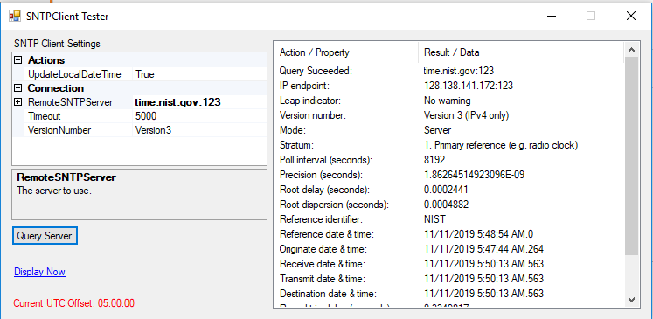

1. **Edit the code to get the time from ten servers and display, also calculate the time difference with multiple time servers.**

By changing the UTC every time, the server End IP also changes due to change in time (server replying changes.) This change can be observed in the screenshots attached. Diff is in millisecond.

These times are recorded on 11/11/2019

Asia Server

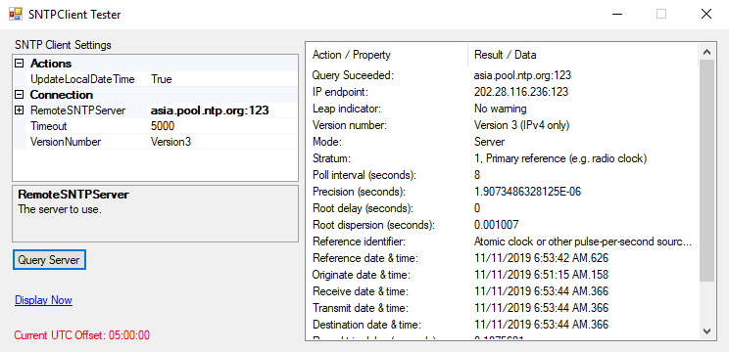

Europe Server

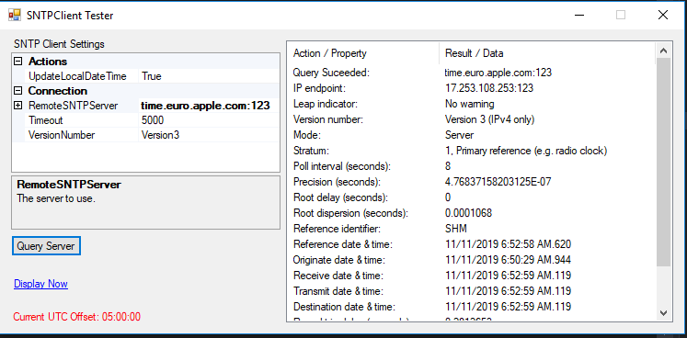

These times are recorded on 17/11/2019

Asia Server

Europe Server

Africa server

